March 5, 2024
Ref: IIH/MD/2024/03/006

His Excellency,
The Executive Governor of Kwara State,
Government House,
Ahmadu Bello Way,
GRA, Ilorin, Kwara State

Your Excellency Sir,

VISIT REPORT AND REQUEST FOR APPROVAL TO RELEASE FUNDS FOR REIMBURSEMENT OF COSTS INCURRED DURING VISIT OF DELEGATION OF DEPUTY HIGH COMMISSION OF CANADA ON TRADE VISIT TO KWARA STATE

I write to request approval to release funds for the reimbursement of costs incurred during the visit of the Trade Delegation of the Deputy High Commission of Canada to Kwara State from February 12th to 14th 2024. The trip was a huge success as they were able to visit different projects and companies in the Tech and Agricultural industries. This has already led to follow-up meetings and collaboration. The costs were incurred to ensure we met the high security standards required of foreign embassies and also to entertain the guests. Some of the projects visited are:

- Ilorin Innovation Hub
- Sugar Factory Film Studios
- Institute for Contemporary Art and Film
- Flower Gardens

The delegation also visited private companies like:
- Malhub
- Plat Technologies
- Fairshop

A breakdown of costs is given below:

SN |  | Days | Rate | Amount
1 | Logistics & Transportation | 3 | 100,000 | 300,000
2 | Entertainment & Feeding | 3 | 50,000 | 150,000
 | Sub-Total |  |  | 450,000
 | Charges & VAT 20%** |  |  | 90,000
 | Total |  |  | 540,000

Yours sincerely,
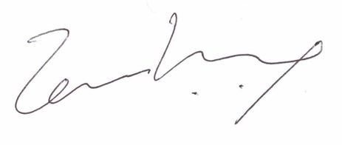
Temi Kolawole
ag. Managing Director

